Pan-London Symptom Control Medication Authorisation and Administration Record (MAAR): Chart for subcutaneous and intramuscular medication in the community setting

Version 4
Circulated Date: 8th February 2022 Agreed Date: 8th December 2021 Review Date: 8th December 2023 Use from: 3rd May 2022

This document will continue to be reviewed and re-released to reflect new and emerging evidence.

‘AS REQUIRED’ (PRN) SUBCUTANEOUS INJECTIONS AUTHORISATION AND ADMINISTRATION CHART V4

Please indicate here ☐ if there is more than one ‘As required’ authorisation and administration chart in use
This document should remain with the patient. These charts are only for injectable medicines.
Tick this box if another Community Drug Chart is in use e.g. for Patches, Enemas etc. ☐
Palliative Care Team Contact Details:  Add a local contact: in Redbridge = Redbridge Mac Team 03003001901. In B&D Havering and Brentwood = Saint Francis Hospice 01708 758643 | Authorising clinician name and GMC/NMC/GPhC number:  YOUR NAME IN CAPITALS AND YOUR GMC NUMBER or NMC or GPhC number
Patient Information | Allergies and Adverse Reactions
Patient Name: e.g. Mr AB CRISIS | No Known Allergies: ☐ Known Allergies ☐
 | If required, seek source of allergy
NHS No: xxxxxxxxx | List Medicine/Substance and Reaction: PLEASE DO TICK BOX AND ADD ALLERGIES, PLUS REACTIONS IF POSS
D.O.B aa/bb/cccc | Print, Sign & Date:
Weight (for children):
Check if there is an analgesic transdermal patch: Y ☐ N  Drug name: Dose:
NB: Max 24hour dose below = PRN medications only (i.e. does not include medication administered via syringe pump)

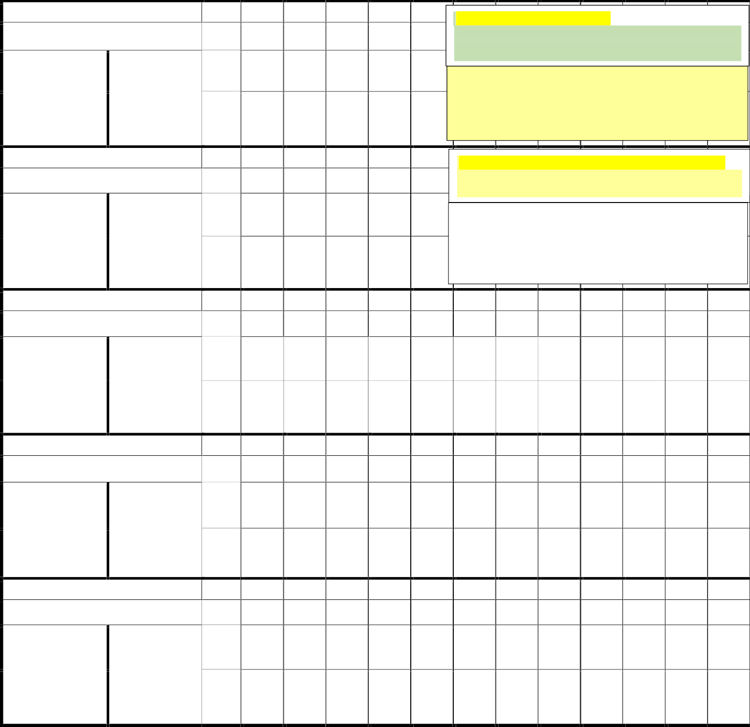
Pain +/or Breathlessness
Medication: MORPHINE SULFATE
Date: Time:

For patients already on opioids, refer to NELFT Palliative Care EOL Quick Reference Guide V4 P6 or ring SFH Advice Line on 01708 758643

Date: x.y.zz

Dose Range:
2.5mg to 5mg
Frequency:1 hrly max
Nausea / Vomiting
Max 24hour dose: 15mg

Authoriser sign & print:
YOUR
NAME/sign
Dose:

Sign:

Date:

If eGFR < 30, or if high clinical suspicion of severe renal failure, use oxycodone instead of morphine, start dose range 1mg to 2mg.

Frequency 1hrly max. Max 24hr dose 10mg

If severe renal failure a/a, or frail ++, use Haloperidol for

Medication: LEVOMEPROMAZINE Time: nausea as less sedating/favoured. Dose 500 micrograms to 1mg Frequency 4 hrly max. Max 24hour dose 5mg

Date: x.y.zz

Dose Range:
6.25mg to 12.5mg

Frequency: 4 hrly max
Max 24hour dose: 25mg

Authoriser sign & print:
YOUR
NAME/sign
Dose:

Sign:

If history of Parkinson’s | .
Use cyclizine instead of levomepromazine,
Dose 50mg (cannot give a range)

Frequency 4hrly max. Max 24hour dose 150mg

Agitation / Distress
Medication: MIDAZOLAM
Date: Time:

Date: x.y.zz

Dose Range:
2.5mg to 5mg

Frequency:1 hrly max
Max 24hour dose: 15mg

Authoriser sign & print:
YOUR
NAME/sign
Dose:

Sign:

Respiratory secretions
Medication: GLYCOPYRRONIUM
Date: Time:

Date: x.y.zz

Dose Range:
200micrograms to
300 micrograms | print:
Frequency: 4 hrly max | YOUR  NAME/sign
Other indication: |  | Date:
Medication: |  | Time:
Date: | Max 24hour dose: | Dose:
Dose Range:

Max 24hour dose: 1.2mg

Authoriser sign &
Dose:

Sign:

Frequency:

Authoriser sign & print:
Sign:

24 HOURS CONTINUOUS SUBCUTANEOUS INFUSION (SYRINGE PUMP) AUTHORISATION CHART V4
NB: If more than one syringe pump is being used at the same time, please use a separate Authorisation Chart for each pump, and indicate here:
Pump (insert no) of (insert no)
This document should remain with the patient. These charts are only for injectable medicines.
Tick this box if another Community Drug Chart is in use e.g. for Patches, Enemas etc. ☐
Palliative Care Team Contact Details:  Add a local contact: in Redbridge = Redbridge Mac Team 03003001901. In B&D Havering and Brentwood = Saint Francis Hospice 01708 758643 | Authorising clinician name and GMC/NMC/GPhC number:  YOUR NAME IN CAPITALS AND YOUR GMC NUMBER or NMC or GPhC number
Patient Information | Allergies and Adverse Reactions
Patient Name: e.g. Mr AB CRISIS | No Known Allergies: ☐ Known Allergies ☐
 | If required, seek source of allergy
NHS No: xxxxxxxxx | List Medicine/Substance and Reaction: PLEASE DO TICK BOX AND ADD ALLERGIES, PLUS REACTIONS IF POSS
D.O.B aa/bb/cccc | Print, Sign & Date:
Weight (for children):

Check if there is an analgesic transdermal patch: Y ☐ N  Drug name: Dose:
Pain and / or Breathlessness For patients already on opioids, refer to NELFT Palliative Care EOL Quick Reference Guide V4 P6 or ring SFH Advice Line on 01708 758643

Date: xx/yy/zzzz Medication: MORPHINE SULFATE

Nausea / Vomiting
Dose range: 10mg to 20mg
(over 24 hours)
If eg R < 30, or if high clinical suspicion of severe renal failure, use Alfentanil as safest opioid, starting dose range 500mcg to 1mg

If severe renal failure a/a, or frail ++, use
Authoriser sign & print:
YOUR NAME /SIGN

Date: xx/yy/zzzz
Medication: LEVOMEPROMAZINE
Dose range: 6.25mg to 12.5mg
(over 24 hours)
Halop ridol for nausea as less sedating/is favoured, starting dose range 1.5mg to 3mg
If history of Parkinson’s and already on
Authoriser sign & print:
YOUR NAME /SIGN

Agitation / Distress IF NEEDED
Date: xx/yy/zzzz Medication: MIDAZOLAM Dose range: 10mg to 20mg
(over 24 hours)
cyclizine prn ring SFH Advice Line for advice

Authoriser sign & print:
YOUR NAME /SIGN

Respiratory tract secretions IF NEEDED
Date: xx/yy/zzzz Medication: GLYCOPYRRONIUM Dose range: 600 micrograms to 1.2mg
(over 24 hours)

Authoriser sign & print:
YOUR NAME /SIGN

Other medication – specify indication here:
Date: Medication: Dose range: (over 24 hours)

Authoriser sign & print:

Other medication – specify indication here:
Date: Medication: Dose range: (over 24 hours)

Authoriser sign & print:

Diluent
Date: xx/yy/zzzz Diluent: WATER FOR INJECTIONS Authoriser sign & print:
YOUR NAME /SIGN

CRISIS/EMERGENCY AND REGULAR INJECTIONS AUTHORISATION AND ADMINISTRATION CHART
V4
This document should remain with the patient.
These charts are only for injectable medicines. Tick this box if another Community Drug Chart is in use e.g. for Patches, Enemas etc. ☐
If more than one syringe pump is being used, please use a separate syringe pump Authorisation Chart
Palliative Care Team Contact Details:  Add a local contact: in Redbridge = Redbridge Mac Team 03003001901. In B&D Havering and Brentwood = Saint Francis Hospice 01708 758643 | Authorising clinician name and GMC/NMC/GPhC number:  YOUR NAME IN CAPITALS AND YOUR GMC NUMBER or NMC or GPhC number
Patient Information | Allergies and Adverse Reactions
Patient Name: e.g. Mr AB CRISIS | No Known Allergies: ☐ Known Allergies ☐
 | If required, seek source of allergy
NHS No: xxxxxxxxx | List Medicine/Substance and Reaction: PLEASE DO TICK BOX AND ADD ALLERGIES, PLUS REACTIONS IF POSS
D.O.B aa/bb/cccc | Print, Sign & Date:
Weight (for children):

CRISIS / EMERGENCY SUBCUTANEOUS AND INTRAMUSCULAR INJECTIONS
Indication: SEIZURES |  | Administration record: |  | Administration record: |  | Administration record:
Medication: MIDAZOLAM |  | Date: |  | Date: |  | Date:
 |  | Time: |  | Time: |  | Time:
Dose: 5mg to 10mg | Route: IM | Dose: |  | Dose: |  | Dose:
Max 24hour dose: 60mg | Frequency: 1/2hr | Sign: |  | Sign: |  | Sign:
Authoriser sign, print & date: YOUR NAME /SIGN/ xx/yy/zzzz
Indication: LARGE HAEMMORHAGE |  | Administration record: |  | Administration record: |  | Administration record:
Medication: MIDAZOLAM |  | Date: |  | Date: |  | Date:
 |  | Time: |  | Time: |  | Time:
Dose: 5mg to 10mg | Route: IM | Dose: |  | Dose: |  | Dose:
Max 24hour dose: 60mg | Frequency: 1/2hr | Sign: |  | Sign: |  | Sign:
Authoriser sign, print & date: YOUR NAME /SIGN/ xx/yy/zzzz

REGULAR DOSE SUBCUTANEOUS INJECTIONS
Indication: IF UNABLE TO MANAGE ORAL STEROID | Date:
Medication: DEXAMETHASONE | Enter administration times | 10am
Dose: 6.6mg OD
Authoriser sign, print & date:
YOUR NAME /SIGN/ xx/yy/zzzz
Indication: | Date:
Medication: | Enter administration times
Dose:
Authoriser sign, print & date:

